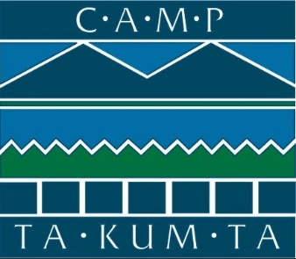

Ribbon-Cutting to Celebrate Camp Ta-Kum-Ta’s Holly D. Miller Pavilion
Camp Ta-Kum-Ta will celebrate the completion of a multi-purpose pavilion space to serve the needs of children who have or have had cancer and their families.
South Hero, Vermont, July 17 – Camp Ta-Kum-Ta staff, board members, and supporters will gather to celebrate the completion of the Holly D. Miller Pavilion with a ribbon-cutting ceremony at Camp Ta-Kum-Ta on July 17th at 5:00pm. This project was made possible thanks to generous support from Case and Judy Carpenter, Dealer.com, Dragonheart Vermont, Robert & Holly Miller, The George W. Mergens Foundation, The Hoehl Family Foundation, The Pizzagalli Family, and Vermont Mutual Insurance Group along with other generous individuals and businesses in our community.
The project was intended to provide a safe, permanent structure where campers - children who have or have had cancer - can enjoy food, conversation, and song and make many of their most special memories and connections during Camp Ta-Kum-Ta’s year-round programs! Work began last fall and continued through the winter.
This new space is a 40 x 100 open-air, steel-framed structure equipped with drop-down screen sides, large fans, A/V features, and a sprinkler system to maximize safety, comfort, and functionality regardless of weather. It will serve at Camp Ta-Kum-Ta’s dining hall during their summer program, a gathering space for guests during camp events and programs for families, siblings, and parents, and as a home for the Camp TKT ice rink during Camp Ta-Kum-Ta Winter Weekends.
“We are so grateful for all who helped make this pavilion possible. This permanent fixture will be part of many fun memories made singing meal-time songs, playing games, connecting with friends, and skating in the winter, just to name a few. I can’t wait to see the smiles on our campers’ and volunteers’ faces – this space is just what we needed to continue providing safe, memorable moments for children with cancer and their families in the best and most fiscally responsible way for many years to come,” noted Hattie Johnson, Camp Ta-Kum-Ta’s Executive Director.
About Camp Ta-Kum-Ta
For 34 years, the common denominator at Camp Ta-Kum-Ta has been childhood cancer, but the staff is dedicated to helping campers and families forget about their cancer, make lifelong friendships, and have the time of their lives! They give children a place to feel normal, happy, and loved whether going through treatment or in remission.
Camp Ta-Kum-Ta provides challenging, extraordinary experiences in a safe and loving environment for children who have or have had cancer and their loved ones. Camp serves Vermont and Northern New York children (including other out-of-state children who are treated in Vermont) at no cost to their families.
Throughout the year Camp Ta-Kum-Ta squeezes in as many life experiences and memories as possible. Along with traditional camp activities such as swimming, athletics, ropes course, and arts & crafts, Camp Ta-Kum-Ta offers once-in-a-lifetime opportunities such as rock climbing expeditions, hot-air balloon rides, formal dances, and barn dances. During the winter they host holiday parties and winter weekends where kids go cross country skiing, snowshoeing, ice skating and much more. Additionally, Camp TKT provides weekends for siblings, moms, and dads of current campers.
Camp TKT does not receive any state or federal funding. Their support comes from individuals, businesses, corporations, and foundations who strive to be a hero to the children that need it most.

